Implementing TDMA Slot Allocation in GSM. Date
Objective 1
clc;
clear;
close all;

FrameTime = 4.615; % Frame Time (ms)
Slots = 8; % Number of Time Slots

% Duration of each slot
SlotDuration = FrameTime / Slots;

% Time vector for 8 slots
t = 0:SlotDuration:(FrameTime - SlotDuration);

% Create figure
figure;

% TDMA Time Slot Structure
subplot(2,1,1);
stem(t, ones(size(t)), 'filled', 'LineWidth', 1.5);
title('TDMA Time Slot Structure');
xlabel('Time (ms)');
ylabel('Slot Level');
grid on;

% Continuous View of Slot Allocation
subplot(2,1,2);
plot(t, ones(size(t)), '-o', 'LineWidth', 1.5);
title('Continuous View of Slot Allocation');
xlabel('Time (ms)');
ylabel('Slot Presence');
grid on;
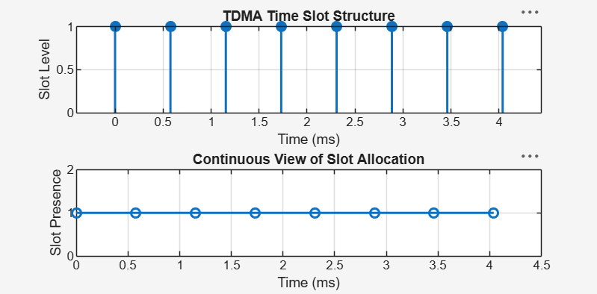

Objective 2
clc;
clear;
close all;

% GSM Frame Slot Configuration
TotalSlots = 8;
AllocatedSlots = 6;

% Calculate Free Slots
FreeSlots = TotalSlots - AllocatedSlots;

% Calculate Frame Utilization
Utilization = (AllocatedSlots / TotalSlots) * 100;

% Display Results
fprintf('Total Slots : %d\n', TotalSlots);
fprintf('Allocated Slots : %d\n', AllocatedSlots);
fprintf('Free Slots : %d\n', FreeSlots);
fprintf('Frame Utilization: %.2f%%\n', Utilization);

% Create Figure
figure;

% Graph 1: Allocated vs Free Slots
subplot(2,1,1);
plot([1 2], [AllocatedSlots FreeSlots], '-o', ...
'LineWidth', 2, 'MarkerSize', 8);

title('GSM Frame Utilization (Allocated vs Free)');
xlabel('Slot Type Index (1 = Allocated, 2 = Free)');
ylabel('Number of Slots');

xticks([1 2]);
xticklabels({'Allocated', 'Free'});
grid on;

% Graph 2: Pie Chart
subplot(2,1,2);
pie([AllocatedSlots FreeSlots]);

title('Slot Distribution in GSM Frame');
legend('Allocated', 'Free', 'Location', 'best');

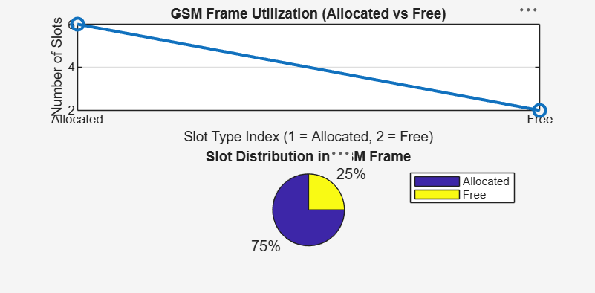

Objective 3
clc;
clear;
close all;

% User and Slot Configuration
Users = 1:8; % Total number of users
TotalSlots = 5; % Available TDMA slots

% Initialize slot allocation
Alloc = zeros(1, length(Users));

% Allocate slots to the first users
Alloc(1:TotalSlots) = 1;

% Identify blocked users
Blocked = 1 - Alloc;

% Display User-wise Slot Allocation
disp('User Wise Slot Allocation');

AllocationTable = table(Users', Alloc', ...
'VariableNames', {'User', 'Status'});

disp(AllocationTable);

% Create Figure
figure;

% Graph 1: Allocation per User
subplot(2,1,1);

stem(Users, Alloc, 'filled', 'LineWidth', 2);

title('TDMA Slot Allocation per User');
xlabel('User Index');
ylabel('Slot Status (1 = Allocated, 0 = Blocked)');

ylim([-0.2 1.2]);
xticks(Users);
grid on;

% Graph 2: System View
subplot(2,1,2);

plot(Users, Alloc, '-o', 'LineWidth', 2);
hold on;

plot(Users, Blocked, '-s', 'LineWidth', 2);

title('TDMA Slot Utilization Analysis');
xlabel('User Index');
ylabel('Status');

ylim([-0.2 1.2]);
xticks(Users);

legend('Allocated', 'Blocked', 'Location', 'best');
grid on;

hold off;
